

Undergraduate Lab Report

Course Title: Experiment of Computer Organization
Course No: 60080014
Student Name: 蒋云翔
Student No: 2022102330
School: 暨南大学
Department: 国际学院
Major: CST
Instructor： SUN Heng

Academic Year:2023~2023,Semester : 1st [ √ ] 2nd[ ]

Academic Affairs Office of Jinan University
Date (dd/mm/yyyy)___10/10/2020____
Computer Organization Lab List
Student Name: 蒋云翔 Student No: 2022102330

ID | Lab Name | Type
1 | Number Storage Lab | Individual
2 | Manipulating Bits | Individual
3 | Simulating Y86-64 Program | Individual
4 | Performance Lab | Team
5 | A Simple Real-life Control System | Team
6 | System I/O | Individual
Undergraduate Lab Report of Jinan University
Course Title Experiment of Computer Organization Evaluation
Lab Name Number Storage Lab Instructor SUN Heng
Lab Address 116
Student Name 蒋云翔 Student No 2022102330
College 暨南大学
Department 国际学院 Major CST
Date 10 / 10 / 2023 Morning / Afternoon
- Introduction

This lab extends the section Information Storage (chapter 2) in the textbook. It will immerse you in a problem context, which will require you to apply the theoretical concepts taught in the C language course. This will help you to develop basic skills needed to become a device level system developers and digital system designer. While going through this lab concentrate on developing a good understanding of the problem context, as it is a fundamental requirement for becoming a skilled system designer or application developer.

- Lab Instructions or Steps

You are provided with the C program. This code (file name “lab1.c”) is available from the course materials.

Activities to do-

a) Using less than 4 sentences, explain what function/action, the two statements marked with “Tag 1” and “Tag 2” perform.

b) Compile and run this program with “gcc” on the Linux machine.

c) When you ran your code, did you get the time executed to be negative? If yes, why did that happen? (Since time cannot be negative). How could you fix this? Figure out how to fix it and do the necessary modifications.

d) Change the data type of the variable time_stamp from double to long int. Is there a change in the values reported? If so, which of the values is the correct value? Why is there a difference?

e) Find out the structure of type “timeval”. Is it a standard C data type or is it platform specific?

f) Print your output files for all runs in your report. (and the fixed versions if you made changes above ). Note: If you submit an output file with negative time, you must submit the corrected version also. Failure to do so will lead to loss of 50% of the points for this lab.

g) Write a C program to get bit and byte lengths for all the following C numerical data types according to the following table. The new C code file should have name “lab1_2.c” and it should generate an output file named “lab1_2_out.txt”. Hint – You can add codes to the lab1.c program to do this step.
- 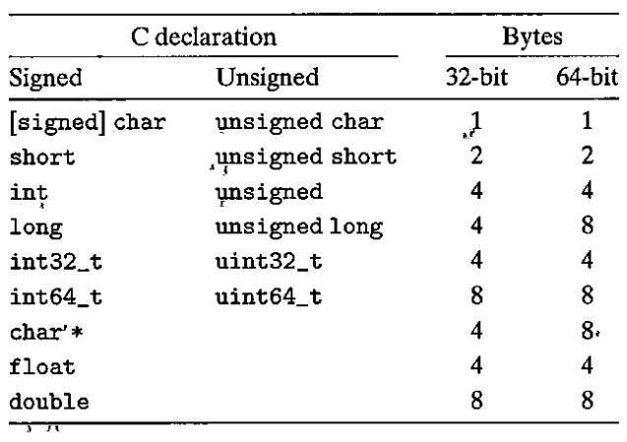
Figure 1 Typical sizes (in bytes) of basic C data types (from figure 2.3 in the textbook)

- Lab Device or Environment
Vmware workstation pro & Ubuntu16.04

- Results and Analysis
(a)
"Tag 1" declares an integer variable named int_var.
"Tag 2" prints the size of the int data type in bytes and bits on the console.

(b) 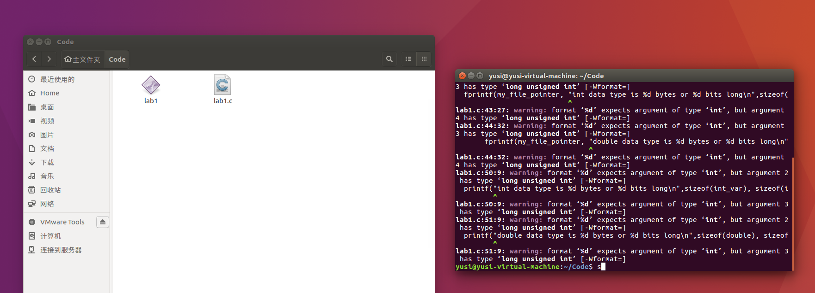
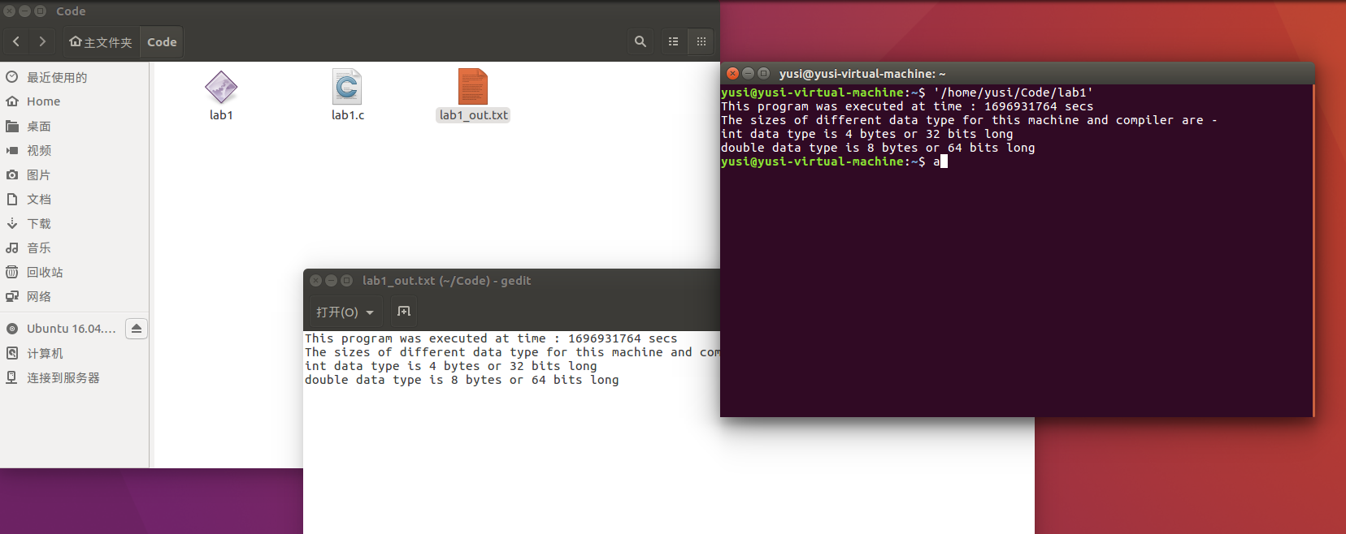
(c)
I did not get the time executed to be negative, but the situation that may be due to the fact that the variable used to store the timestamp is of double data type and it could be negative in certain cases. One way to fix this is to update the data type of the time_stamp variable to unsigned long long as it is guaranteed to always be positive.
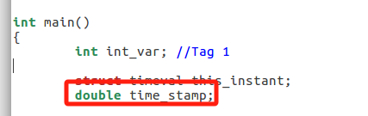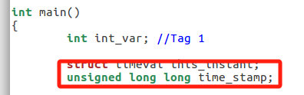

(d)
Changing the data type of the variable time_stamp from double to long int may result in a difference in the reported values. If there is a difference, the long int value would be considered correct. The difference arises because the double data type can store fractional parts, while the long int data type only stores integer values.
If time_stamp is a double variable, it can hold a timestamp with a decimal part, for example, 1633824489.54321. When it is printed using the %ld format specifier as a long int, the decimal part will be discarded, and only the integer part, which is 1633824489, will be displayed.

(e)
The structure type "timeval" is defined in the header file "sys/time.h" and is platform specific. It is used to represent time with microsecond precision.

(f)
Double：↓
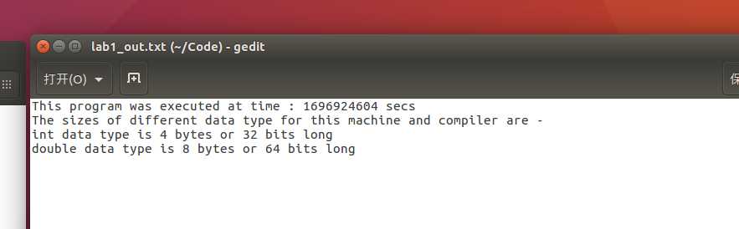

Unsigned long：↓
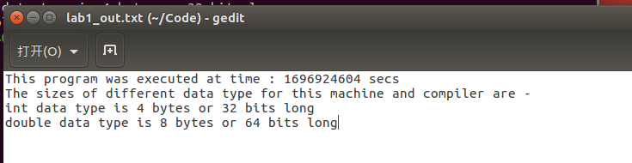
(g)
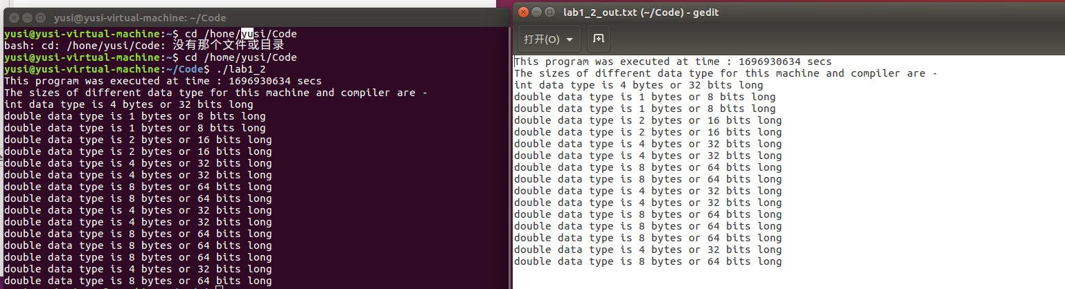
- Appendix (Program Code)
/*
Instructions -

To run this program - first compile to crete an executable,
then run the executable code.

Type the following in the Linux console/shell to compile and make an executable using the gcc complier-

gcc lab1.c -o lab1

To run the executable named "lab1", type the following-

./lab1
*/

#include <stdio.h> //For input/output
#include <stdint.h> //For int32_t
#include <sys/time.h> //For gettimeofday() function

int main()
{
int int_var; //Tag 1

struct timeval this_instant;
unsigned long time_stamp;

FILE *my_file_pointer;
if ( (my_file_pointer = fopen("lab1_2_out.txt", "w")) == NULL)
{
printf("Error opening the file, so exiting\n");
exit(1);
}

gettimeofday(&this_instant,0);
time_stamp = this_instant.tv_sec;

//Code segment for file I/O
fprintf(my_file_pointer, "This program was executed at time : %d secs\n", (int)time_stamp);

fprintf(my_file_pointer, "The sizes of different data type for this machine and compiler are -\n");
fprintf(my_file_pointer, "int data type is %d bytes or %d bits long\n",sizeof(int_var), sizeof(int_var)*8 );
fprintf(my_file_pointer, "double data type is %d bytes or %d bits long\n",sizeof(signed char), sizeof(signed char)*8 );
fprintf(my_file_pointer, "double data type is %d bytes or %d bits long\n",sizeof(unsigned char), sizeof(unsigned char)*8 );
fprintf(my_file_pointer, "double data type is %d bytes or %d bits long\n",sizeof(short), sizeof(short)*8 );
fprintf(my_file_pointer, "double data type is %d bytes or %d bits long\n",sizeof(unsigned short), sizeof(unsigned short)*8 );
fprintf(my_file_pointer, "double data type is %d bytes or %d bits long\n",sizeof(int), sizeof(int)*8 );
fprintf(my_file_pointer, "double data type is %d bytes or %d bits long\n",sizeof(unsigned), sizeof(unsigned)*8 );
fprintf(my_file_pointer, "double data type is %d bytes or %d bits long\n",sizeof(long), sizeof(long)*8 );
fprintf(my_file_pointer, "double data type is %d bytes or %d bits long\n",sizeof(unsigned long), sizeof(unsigned long)*8 );
fprintf(my_file_pointer, "double data type is %d bytes or %d bits long\n",sizeof(int32_t), sizeof(int32_t)*8 );
fprintf(my_file_pointer, "double data type is %d bytes or %d bits long\n",sizeof(uint32_t), sizeof(uint32_t)*8 );
fprintf(my_file_pointer, "double data type is %d bytes or %d bits long\n",sizeof(int64_t), sizeof(int64_t)*8 );
fprintf(my_file_pointer, "double data type is %d bytes or %d bits long\n",sizeof(uint64_t), sizeof(uint64_t)*8 );
fprintf(my_file_pointer, "double data type is %d bytes or %d bits long\n",sizeof(char*), sizeof(char*) * 8);
fprintf(my_file_pointer, "double data type is %d bytes or %d bits long\n",sizeof(float), sizeof(float)*8 );
fprintf(my_file_pointer, "double data type is %d bytes or %d bits long\n",sizeof(double), sizeof(double)*8 );

//Code segment for console I/O, this can be used instead of the file I/O
printf("This program was executed at time : %d secs\n", (int)time_stamp);

printf("The sizes of different data type for this machine and compiler are -\n");
printf("int data type is %d bytes or %d bits long\n",sizeof(int_var), sizeof(int_var)*8 ); //Tag 2
printf( "double data type is %d bytes or %d bits long\n", sizeof(signed char), sizeof(signed char) * 8 );
printf( "double data type is %d bytes or %d bits long\n", sizeof(unsigned char), sizeof(unsigned char) * 8 );
printf( "double data type is %d bytes or %d bits long\n", sizeof(short), sizeof(short) * 8);
printf( "double data type is %d bytes or %d bits long\n", sizeof(unsigned short), sizeof(unsigned short) * 8);
printf( "double data type is %d bytes or %d bits long\n", sizeof(int), sizeof(int) * 8);
printf( "double data type is %d bytes or %d bits long\n", sizeof(unsigned), sizeof(unsigned) * 8);
printf( "double data type is %d bytes or %d bits long\n", sizeof(long), sizeof(long) * 8);
printf( "double data type is %d bytes or %d bits long\n", sizeof(unsigned long), sizeof(unsigned long) * 8);
printf( "double data type is %d bytes or %d bits long\n", sizeof(int32_t), sizeof(int32_t) * 8);
printf( "double data type is %d bytes or %d bits long\n", sizeof(uint32_t), sizeof(uint32_t) * 8);
printf( "double data type is %d bytes or %d bits long\n", sizeof(int64_t), sizeof(int64_t) * 8);
printf( "double data type is %d bytes or %d bits long\n", sizeof(uint64_t), sizeof(uint64_t) * 8);
printf( "double data type is %d bytes or %d bits long\n", sizeof(char*), sizeof(char*) * 8);
printf( "double data type is %d bytes or %d bits long\n", sizeof(float), sizeof(float) * 8);
printf( "double data type is %d bytes or %d bits long\n", sizeof(double), sizeof(double) * 8);

fclose(my_file_pointer); //To close the output file, mandatory to actually get an output !

return 0;
}

